**Technological trends on the marketing industry**

Augmented reality AR ads that let the user see the promoted content in an interactive manner, bringing it to their own present reality.

Video content Video is used to promote content with lots of information in a short span, cab ne key in paid social campaigns where the time slot is short.

Personalized digital pitch You need to build relationships with reporters and editors if you want to increase your chance of getting your content published fast. If you want to stand out, you should first connect with them on social media.

Digital data analytics Includes methods of understanding consumer behaviour in the digital world, such as number of clicks, views, likes, and interactions though online platforms.

Software and digital services Technology introduced software and digital services that allow companies to do statistical analysis on their market performance

Automation and artificial intelligence AI and automation can be used to improve the effectiveness of their sales teams, to gather data for “flexible, targeted coaching” to free sales teams to spend more time closing deals.

Mobile commerce Creating mobile commerce by developing mobile friendly websites and, ultimately, apps where customers can shop through their mobile devices.

Online visibility Use SEO to increase brand visibility by having a broad online visibility so your business can be easily found by people that are interested in your industry

Live videos Live videos are available on several social media, where brands can broadcast their content and make it interactive with the consumers.

Digital communications technology trends impact the marketing industry in many different ways.

Benefits that businesses can get from that include a much broader reach for their content, being able to be spread worldwide in just a few seconds. Also, interactive content create more engagement and stronger relationships between company and consumer. Another pro is that, with technology, it is easier for companies to analyse the market and understand their needs, since feedback is given directly and in real time.

However, there are concerns about digital marketing practices. Issues with intellectual property can be bigger, since it is easier to hack and steal digital content, which would be quickly sent around, and once it is done in the digital world, it is hard to reverse. There are also regulations that need to be considered in digital trends such as spam. Another concern that organisations should have is that, with so many technology available and so many different ways to create and deliver content now, it can be easier for a marketing strategy to lose its consistency. Companies need to ensure that their actions across all channels remain consistent, no matter how much technology they use. To create solutions for these issues, it is necessary to have a marketing team that is updated to the technology used and have this team working together, to deliver one only message across all channels. Also, companies may have to consult with specialists on digital practices and regulations to ensure compliance with law. IT specialists may be useful to ensure IP safety when using digital content as well.

The graph below shows how so many companies are using these technologies, but have failed on integrating them, losing consistency:

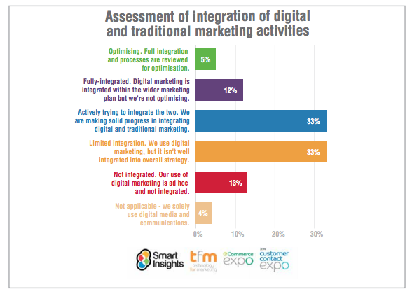

source: https://www.smartinsights.com/managing-digital-marketing/marketing-innovation/marketing-trends-2016/